Role of Haptics in Teaching Structural Molecular Biology

Ganesh Sankaranarayanan , Suzanne Weghorst

Human Interface Technology Laboratory, University of Washington
{ganeshs/weghorst}@u.washington.edu
Michel Sanner, Alexandre Gillet, Arthur Olson

Molecular Graphics Laboratory, The Scripps Research Institute
{sanner/gillet/ olson}@scripps.edu

Abstract

Physical models such as ball-and-stick have long been used in teaching basic chemistry and structural molecular biology. As the size and complexity of known molecular structures increases, it is difficult if not impossible to show all of their features in a physical model alone. Recent advances in automated model fabrication technology now afford physical models of more complex molecular structures. In this multi-institutional collaborative project we are creating multi-modality enhancements of such tangible models by superimposing graphical (augmented reality) information on top of the fabricated physical models, by incorporating support for voice commands, and by providing haptic feedback. The user of such an interface can request a variety of overlay representations and can interact with these virtual enhancements haptically while manipulating the physical model. This multi-modality interface appears to be quite intuitive for observing complex molecular structure. We are currently evaluating its usefulness in teaching molecular biology to high school students.

1. Introduction

Teaching in chemistry and molecular biology has traditionally relied upon physical models. In organic chemistry, ball-and-stick models of up to 100 atoms have been used by educators for decades to present the geometry and flexibility of organic compounds. These physical models provide an intuitive representation of the molecule, allowing students to explore aspects such as bonding and the relationship of structure to function. Since structural molecular biology is based on these same principles, the teaching and understanding of molecular biology should benefit greatly from an appropriate set of physical models.
Unfortunately, the commonly available models become rather cumbersome when applied to large
molecules, such as proteins and the molecular assemblies found in cells. Moreover, since physical models are able to represent only one particular function that they are fabricated for, additional data relating to the structure, function, evolution and genetics of these molecular structures cannot be fully reflected in the shape and color of the physical representation. Computer graphics simulation can be used to accurately portray various molecular computational models, with their varying complexities. Molecular modeling packages using computer graphic simulation are widely available. However, when used on their own these methods lack the beneficial tactile and kinesthetic attributes of the real physical model.
Recent advances in computer aided design and manufacture (CAD/CAM) and in auto-fabrication technology have allowed prototyping and creation of physical models that represent biological molecules at all levels of scale and complexity. By enhancing the information content of these complex physical models we can greatly complement and accelerate the learning process in molecular biology.
Our method to achieve such results consists of using (1) augmented reality [1] to superimpose computational (virtual) models on top of the real physical models, (2) voice commands to free the user’s hands to manipulate the models, and (3) haptic feedback to provide additional information about these augmented models. Using this multi-modal interaction, a variety of computational models can be queried and studied in relation to the underlying physical models.
Since the underlying physical model is intimately related to and registered with both the graphical and haptic models, this approach provides a uniquely integrated tool for learning molecular biology. In addition, haptic cues provide a naturally intuitive method for representing interactions between molecules, based on their electrostatic fields.

2. Background

Haptic rendering of molecular interactions has been extensively studied [2]. The Grope project [3] documented the usefulness of haptic display in the perception of force fields, and demonstrated the application of haptic feedback in molecular docking and drug design. Project GROPE’s Docker system [4,5] has shown that haptic feedback can significantly reduce the time taken to position a molecule in its lowest-energy configuration, compared to visual feedback alone. The more recent Idock system [6], also from the GROPE project, runs both on an Immersadesk and in a fully immersive CAVE environment.
The Interactive Molecular Dynamic (IMD) system [7] permits manipulation of simulated molecules with real-time force feedback and graphical display. Such systems permit the study of binding forces of biomolecules of up to 4000 atoms and their responses to mechanical forces.

3. Methods

Our current approach is based on haptic enhancements to a set of molecular structures that exhibit strong electrostatic or long-range forces. These forces can provide intuitive insight into molecular structure when they are portrayed haptically, using a force display device such as the PHANToM (Sensable Technologies Inc.) or Spidar (Mimic Technologies Inc.) and appropriate interface software.
Our software is constructed as modules within the Python-Based Molecular Viewing (PMV)[8,9] environment, a widely used interactive program for computing and visualizing molecular structure, developed by the Molecular Graphics Lab (MGL) at the Scripps Research Institute (TSRI). Physical models of molecules of interest are generated by MGL using commercially available “3D printing” technologies. To register the graphical (augmented reality) model to the physical model, we use a PMV-wrapped version of the ARToolkit software developed at the University of Washington’s Human Interface Technology (HIT) Lab [1].
In this demonstration a small cube, five of whose sides (except the bottom face) contain fiducial square markers, is attached to the physical model (see Figure 1). This allows for continuous tracking and registration in three-dimensional space. The user display can be either via a head-mounted display (HMD) or a computer monitor, either in a standard desktop configuration or in a co-location frame, such as that available from Reach-In Technologies, Inc.
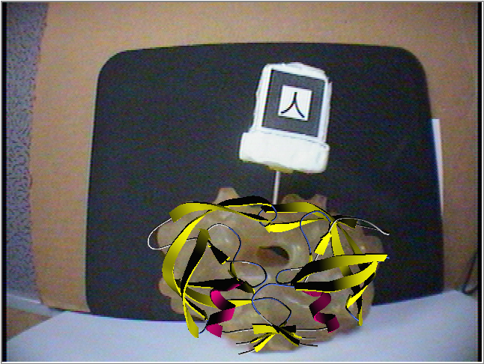
Figure 1. Augmented computational model and physical model with tracking markers.

3.1. Haptic Rendering Framework

Haptic feedback is integrated within PMV as a device-independent software module selectable at runtime. A device-specific interface to the Python module was created using SWIG [10]. A wrapper for the GHOST SDK, the programming environment for the PHANToM, was created specifically for testing the current method. The interface was kept to a minimum, accessing physical position of the encoders of the haptic device and passing forces for haptic rendering.
The block diagram in Figure 2 shows our haptic rendering framework, with the SWIG wrapper connecting the haptic device to the ArtCommands module, thus integrating the core haptic rendering module with the ARToolkit module. New or other haptic devices can be easily added to the existing system by creating the appropriate interface module using SWIG. The haptic module can be ported across platforms with minimal or no changes.
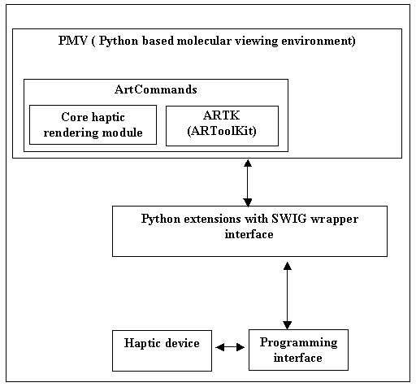
Figure 2. Block diagram showing the haptic rendering framework within PMV.

3.2. Haptic Rendering Module

Since we are currently interested in representing the long-range electrostatic forces, the electrostatic field data around the molecular structure of interest is generated using an electrostatic potential grid map generated by Autogrid [11].
The grid map consists of a three-dimensional lattice of regularly spaced points surrounding the molecular structure of a given model. The gird points are typically spaced between 0.2Å to 1.0Å apart. Each point within the grid map encodes the potential energy of a “probe” atom resulting from its interaction with all the atoms in the molecular structure. Autogrid functions calculate coulombic interactions between the molecule and the probe. No distance cutoff is used for electrostatic interactions. A sigmoidal distance-dependent dielectric function is used to model solvent screening, based on the work of Mehler and Solmajer [12].
Once the grid map containing the potential energy data is computed, a normalized gradient vector at each sampled point is calculated by considering the difference in energy between the sampled point and its six neighboring grid points in (X, Y, Z, -X, -Y, -Z) directions, respectively. The gradients are calculated such that they point toward the lowest energy. For the corner points of the grid (on the edges), which don’t have six neighbors, gradients are assumed null in that direction. The forces at any given point on the volume are then calculated using tri-linear interpolation of the potential energy and gradient at the sampled points.

4. Testing and Results

We first created an electrostatic force grid by using a negative charge probe atom in the volume around a single atom with negative charge. We then tested it with a two-atom model, with one positive and another negative charge to fine tune our force module. For our initial demonstration, we chose to illustrate the workings of superoxide dismutase (SOD), an essential enzyme for cellular functioning which exhibits a strong electrostatic funneling effect in scavenging the superoxide free radical. Figure 3 shows human CuZn superoxide dismutase and the associated charge fields.
In this scenario the user holds the superoxide free radical with the haptic device probe and, as it nears the charge field of the superoxide dismutase, strong forces pull the superoxide free radical toward the Cu and Zn ions at the active site of SOD. At the same time the user sees the secondary structure of the SOD enzyme as an augmented reality overlay on top of the physical model (see Figure 4).

Figure 3. Display of force vector field around active sites of SOD, rendered as secondary (ribbon) structure, with Cu and Zn atoms in CPK
form.

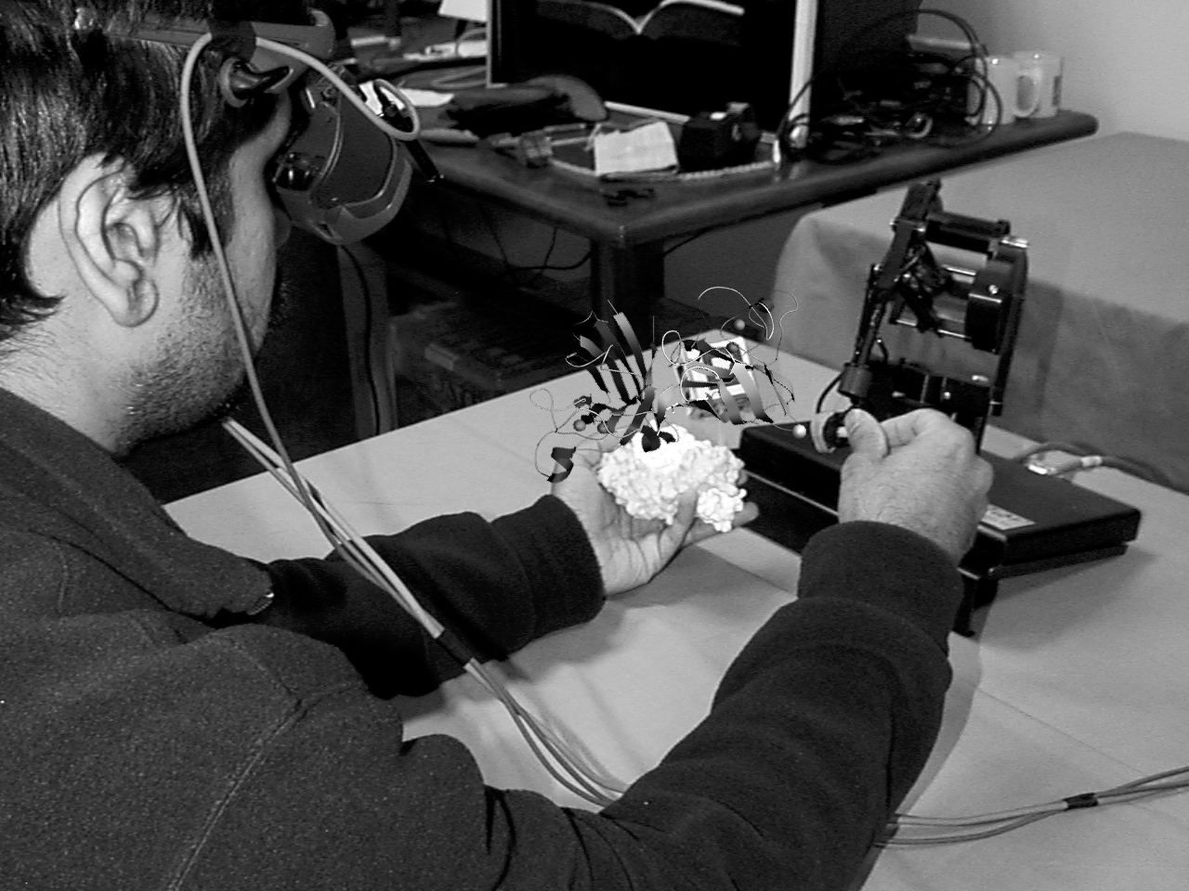

Figure 4. User interacting with SOD model using HMD and PHANToM. Virtual overlay shows SOD secondary structure and force fields.

The use of tangible models coupled with augmented graphical models and haptic feedback provides an intuitive and natural way of understanding the underlying working principle of superoxide dismutase. Initial pilot demonstrations with undergraduate and high school biology students support this hypothesis.

5. Conclusions and Future Work

This demonstration represents an early step in our collaborative exploration of a novel paradigm for multi-modal interaction with tangible molecular models. We are currently developing other instructive examples of molecular structure and interaction for which haptic feedback should provide an intuitive learning interface. We are working closely with teachers from a local high school biotechnology academy and with colleagues in the UW College of Education to develop and assess curricular components using this interface approach.

6. Acknowledgements

This work was supported by research grants from the National Science Foundation (NSF EIA 0121282) and NIH (R33 EB00798).

7. References

[1] Billinghurst, M. and Kato, H., “Collaborative Mixed Reality”, In Proceedings of International Symposium on Mixed Reality (ISMR '99). Mixed Reality--Merging Real and Virtual Worlds, 1999, pp. 261-284.
[2] Brooks, F.P., M. Ouh-Yound, J.J. Batter, and P.J. Kilpatrick, “Project Grope: Haptic displays for scientific visualization”, Computer Graphics: Proc. of SIGGRAPH 90, vol. 24, Aug. 1990, pp. 177-185.
[3] Batter,J.J and Brooks,F.P., Jr. , “GROPE-1:A Computer display to the sense of feel”, Information processing, proc. IFIP Congress 71, 759-763.
[4] Ouh-Yong , G.H. and M., Pique, M., Hughes, J., Srinivasan, N,, Brooks,F.P., Jr, “Using a manipulator for force display in molecular docking”, Proc.IEEE Robotics and Automation Conference 3, Philadelphia, April 1988, pp. 1824-1829.
[5] Ouh-Young,M., “Force display in Molecular Docking”, PhD Dissertation, Computer Science Department, University of North Carolina, Chapel Hill, 1990.
[6] National Center for Supercomputing Applications (NCSA) Idock Project, http://archive.ncsa.uiuc.edu/Vis/Projects/Docker.
[7] Stone, John E., Justin Gullingsrud, Klaus Schulten, Paul Grayson , “A System for Interactive Molecular Dynamics Simulation”, In 2001 ACM Symposium on Interactive 3D Graphics, ACM SIGGRAPH,2001,pp. 191-194.
[8] Sanner, Michel F., Bruce S. Duncan, Christian J. Carrillo and Arthur J. Olson, “Integrating computation and visualization for biomolecular analysis: An example using Python and AVS”, Proc. Pacific Symposium in Biocomputing, 1999, pp 401-412.
[9] Sanner, Michel F., “Python: A programming language for software integration and development”, J. Mol. Graphics Mod,Vol 17, February 1999, pp57-61.
[10] Simplified Wrapper and Interface Generator (SWIG), http://www.swig.org.
[11] Goodsell, D.S. and Olson, A.J ,"Automated docking of substrates to proteins by simulated annealing", Proteins: Str. Func. Genet. , 8 , 1990, pp. 195-202.
[12] Mehler, E.L. and Solmajer, T, "Electrostatic effects in proteins: comparison of dielectric and charge models", Protein Engineering 4 , 1991, pp. 903-910.

